SubSystem title

# ERD for UX process

# 

# Possible UX Interface

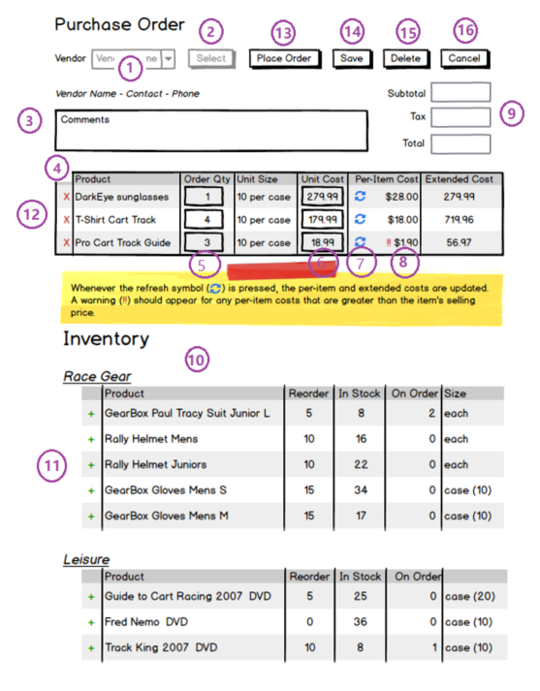

# Activities

|  |  |  |
| --- | --- | --- |
| **Controls** | | **Events** |
| VendorDDL (1) | | None / wired via ObjectDataSource |
| **BLL Class(es) and Method (s)** | | |
| SelectionController | List<SelectionList> List_FindVendorID()  Retrieve a list of VendorName and VendorID for DDL | |
| **SQL Table(s): (C,R,U,D)** | | **ViewModels** |
| Vendors (R) | | SelectionList |

|  |  |
| --- | --- |
| **Controls** | **Events** |
| Select (2),  VendorInfo (3),  POProductsList(4),  OrderQty (5),  UnitCost (6),  Refresh (7),  Worning (8),  Total (9),  Delete (12),  Inventory (10),  Add (11) | OnClick / wired via ObjectDataSource   * Use Vendor selection value (1) and ~~PO with no OrderNumber and OrderDate~~ to search VendorInfo (3) in Vendors and display. * Use Vendor selection value (1) and PO with no OrderNumber and OrderDate to search product list (4) on OrderDetails and display.   Retype OrderQty(5), UnitCost(6) if needed, and update Per-ItemCost and ExtendedCost(7), Subtotal, Tax, Total (9).  If Per-ItemCost is greater than price, display “!!”(8).  Delete product if needed (12).   * Use Vendor selection value (1) and PO with no OrderNumber and OrderDate to search inventory (10) on VendorCatalogs and Products, and display.   Add product to PO if needed. (11) |
| **BLL Class(es) and Method (s)** | |
| VendorController  VendorPOController  InventoryController | 1. List<VendorList> List_VendorInfoForVendorSelection(int vendorID) (1)  Retrieve a list of VendorInfo for selected vendorID.  Return vendorName, Contact, Phone. (3)  2. List<VendorPOList> List_POProductsForVendorSelection(int vendorID) (1)  Retrieve a list of Products on PO for selected vendorID.  Return ProductName, OrderQty, UnitSize, UnitCost, Per-ItemCost, ExtendedCost (4), Return Subtotal, Tax, Total (9)  List<POtotal> List_POTotalForSelection(Int vendorID) (1)  Retrieve a list of subtotal on PO for selected vendorID  3. List<InventoryList> List_ProductsInventoryForVendorSelection(int vendorID)  Retrieve a list of Products Inventory for selected vendorID.  Return ProductName, ReOrder, InStock, OnOrder, Size (10) |
| **SQL Table(s): (C,R,U,D)** | **ViewModels** |
| Vendors (R), Orders(R), OrderDetails(R),  VendorCatalogs (R),  Products(R) | VendorList, VendorPOList, InventoryList |

|  |  |
| --- | --- |
| **Controls** | **Events** |
| Save (14) | Onclick   * Validate required fields (Picked qty, Order Number, PickerID) * Picked quantity validation * All order items have a quantity value * Collect and package data * Send to BLL for processing |
| **BLL Class(es) and Method (s)** | |
| VendorPOController | Void VendorPOList_Update (int OrderQty, smallmoney UnitCost)  TRX   * Verify all products have a valid quantity and UnitCost (greater than zero) * Update OrderDetails for each item on order (qty,Cost) * Check cost is less than price. * Update Orders (TaxGST, SubTotal) * Validate data requirements |
| **SQL Table(s): (C,R,U,D)** | **ViewModels** |
| OrderDetails(U) Orders(U) | VendorPOList |

|  |  |
| --- | --- |
| **Controls** | **Events** |
| PlaceOrder (13) | Onclick   * Generate OrderNumber and OrderDate * Collect and package data * Send to BLL for processing |
| **BLL Class(es) and Method (s)** | |
| VendorPOController | Void VendorPOList_PlaceOrder (int OrderNumber, datetime OrderDate)  TRX   * Update Orders (OrderNumber, OrderDate) * Validate data requirements |
| **SQL Table(s): (C,R,U,D)** | **ViewModels** |
| Orders(U) | VendorOrderList |

|  |  |
| --- | --- |
| **Controls** | **Events** |
| Clear (16) | Onclick  will clear the web page of the current purchase order and reset the vendor list to the vendor prompt line (thus allowing the user to select a new vendor). |
| **BLL Class(es) and Method (s)** | |
|  |  |
| **SQL Table(s): (C,R,U,D)** | **ViewModels** |
|  |  |

# ViewModels:

**SelectionList**

Public varchar(30) VendorName

Public int VendorID

**VendorList**

Public int VendorID

Public varchar(50) Contact

Public varchar(10) Phone

**VendorPOList**

Public int VendorID

Public int OrderID

Public int ProductID

Public varchar ProductName

Public int OrderQty

Public varchar UniteSize

Public smallmoney UniteCost

Public smallmoney PerItemCost

Public smallmoney ExtendedCost

Public smallmoney Subtotal

Public smallmoney Tax

Public smallmoney Total

**InventoryList**

Public int VendorID

Public int ProductID

Public varchar ProductName

Public int Reorder

Public int InStock

Public int OnOrder

Public varchar(50) Size

**VendorOrderList**

Public int OrderID

Public int OrderNumber

Public datetime OrderDate